|  |
| --- |
| ECE 478 - Robotics |
| DIMM Drummer Robot (Leg) |
| Homework #1 – Mechanical Design and Implementation |

|  |
| --- |
| Ommaimah Hussein Mohammed & Solomon Habtemariam  Fall 2014 |

**Objective:**

Our objective was to build a leg for the current DIMM drummer robot that can move and play an instrument.

**Requirements:**

* Material used for designing leg must be similar to the material already used on the DIMM Drummer Robot. (Aluminum/Metal robotic-look)
* Hip will have 2 degrees of freedom. Up/down and right/left.
* Knee will have 1 degree of freedom. Up/down.
* Ankle will have 2 degrees of freedom. Up/down and right/left.

**Design Implementation #1:**

For our first design implementation, we used 2 metal lamps and 5 servos that were located in the Robotics lab. We sketched out our vision on how we wanted to implement it and attached them together mostly by drilling holes, bending thing metal sheets, and tying them together with screws. We put 2 servos on the hip, one on the knee, and 2 on the ankle.

Materials used:

* 2 metal lamps (found in Robotics Lab)
* 5 servos (found in Robotics Lab)

Images:

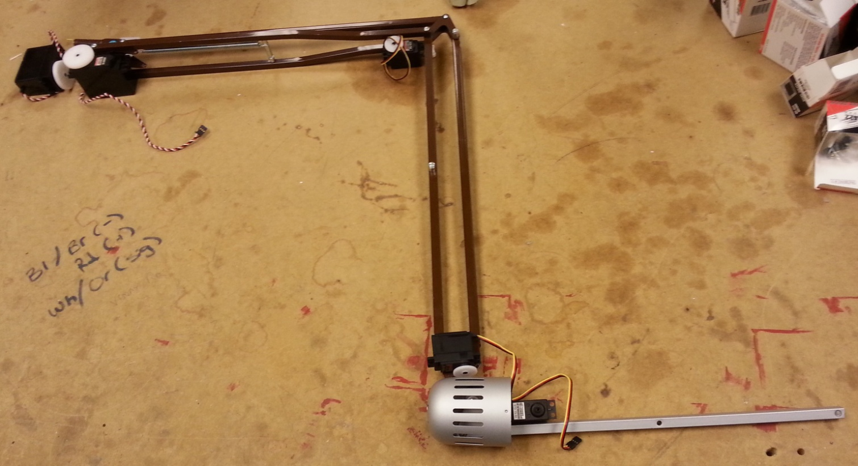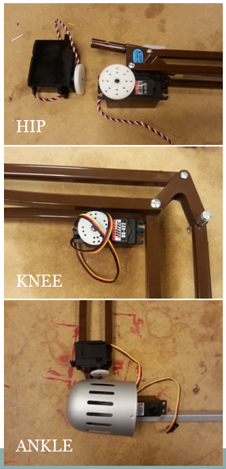

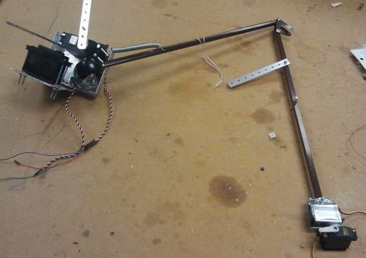

Total Time to Build and Test:

* ~16 hours

Conclusion:

After we finished putting all the material together, we tested the servos and noticed that the servos were not able to pick up the leg due to its heavy weight. The added weight was due to the distance away from the servo which decreased its ability to lift it. We tried removing the second metal bar coming from the hip area and from the knee area, however it was still too heavy for the servos to lift. This design will not work and we had to brainstorm and redesign the leg.

**Design Implementation #2:**

For our second design implementation, we went to Faulk Hardware Store and purchased a thin brass rod to implement since the material was very light. We cut the rod in half and attached it together using hinges to create the knee. We redesigned the hip area to better hold the servo. We then attached the rod to the base of the hips that we designed and attached the servos for the ankles.

Material Used:

* Hinges
* Brass Rod
* 4 servos
* Wood
* Spring

Images:

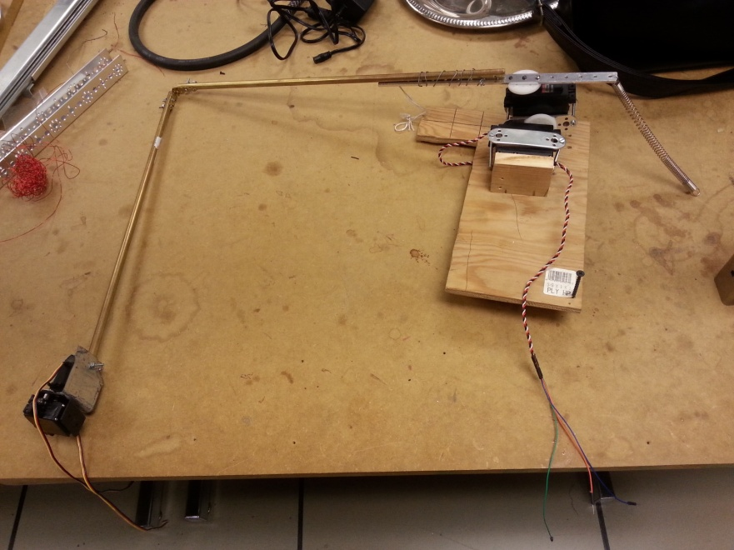

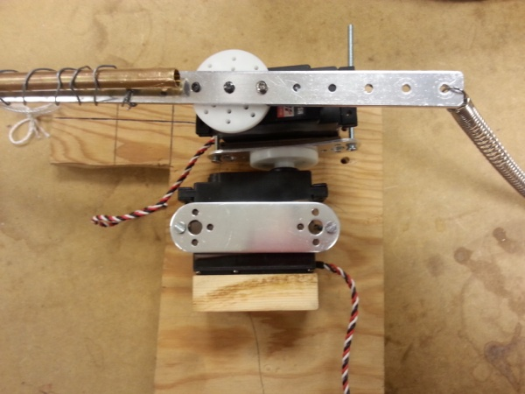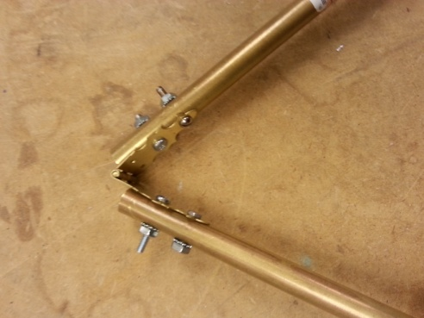

Total Time to Build and Test:

~8 hours

Conclusion:

After we finished assembling all the material together, we tested the servos, and although the metal rod was much light, the servos still struggled to carry the weight. We then implemented a spring on the other side of the hip to help counter the weight the servos were struggling with. This design worked great and the servos were able to live the entire leg. We noticed however that since the metal rod is a circle shape; it wasn’t very structured and occasionally wobbled when the servos were moving. The hinges that held the leg together at the knee came off once in a while and was starting to bend. This design worked, but needs a redesign for a sturdier material that won’t wobble or break, and we also needed to implement the last servo for moving the knee. Therefore, we redesigned one more time to implement these issues.

**Design Implementation #3:**

For our third and final design implementation, we switched out the brass rods for a more sturdy square metal that was taken from a lamp. We came up with several ideas on implementing the last servo to move the knee, some ideas we came up with were servos, gears, or pulleys. If we choose gears, we would add on some more weight which we are avoiding so we decided against using it. We ended up choosing a combo of a servo and a pulley. The extra servo was attached to the hip area and used the pulley to move the knee up. This prevented any extra weight

Material Used:

* Square metal rod (taken from lamp found in Robotics Lab)
* 5 servos
* Wood
* Spring
* 2 Pulleys

Images:

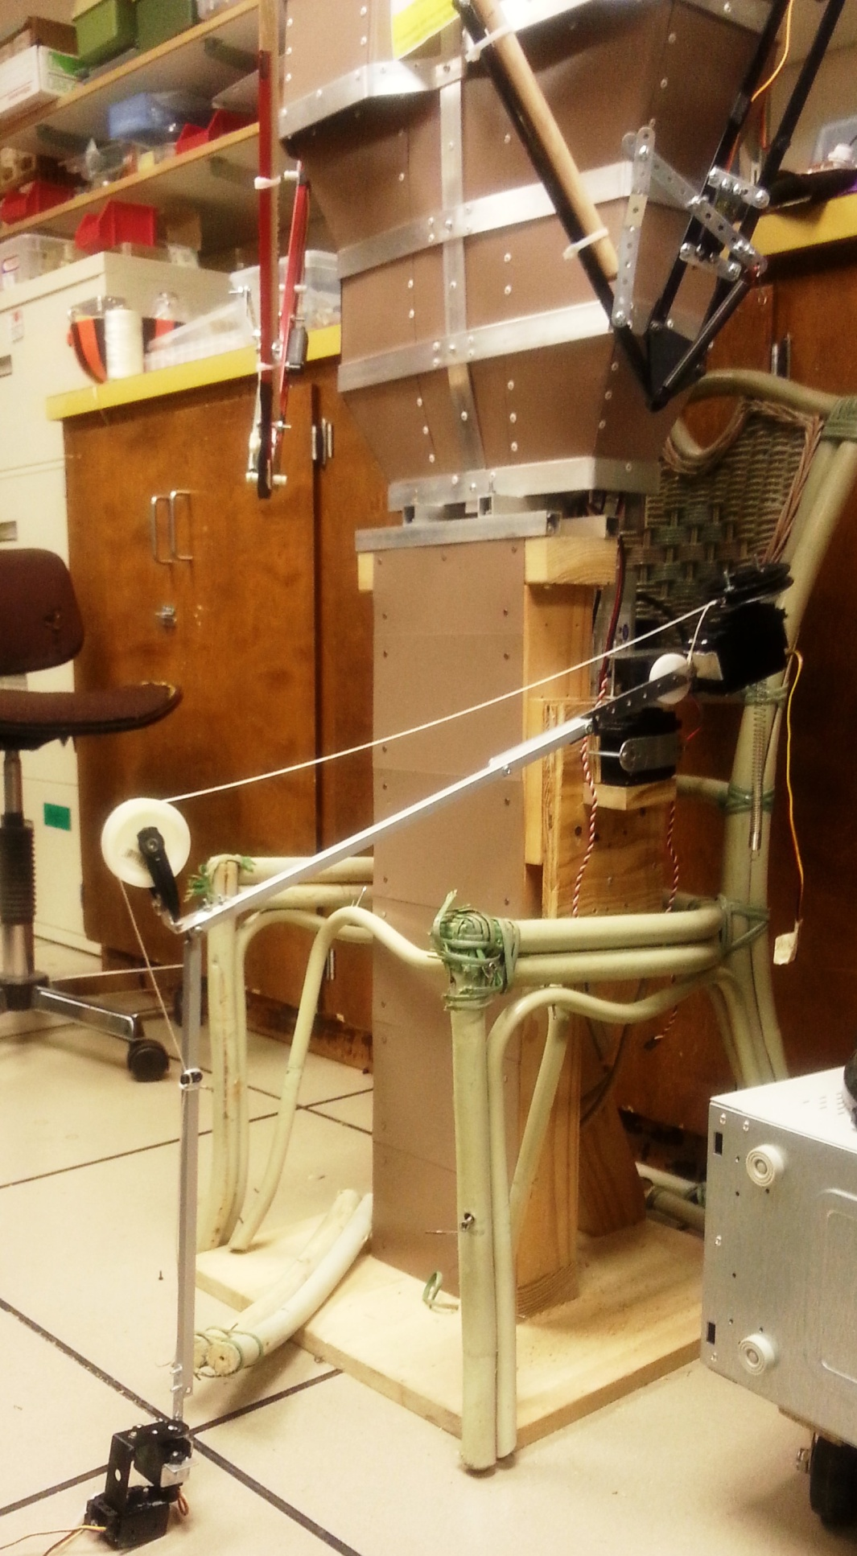

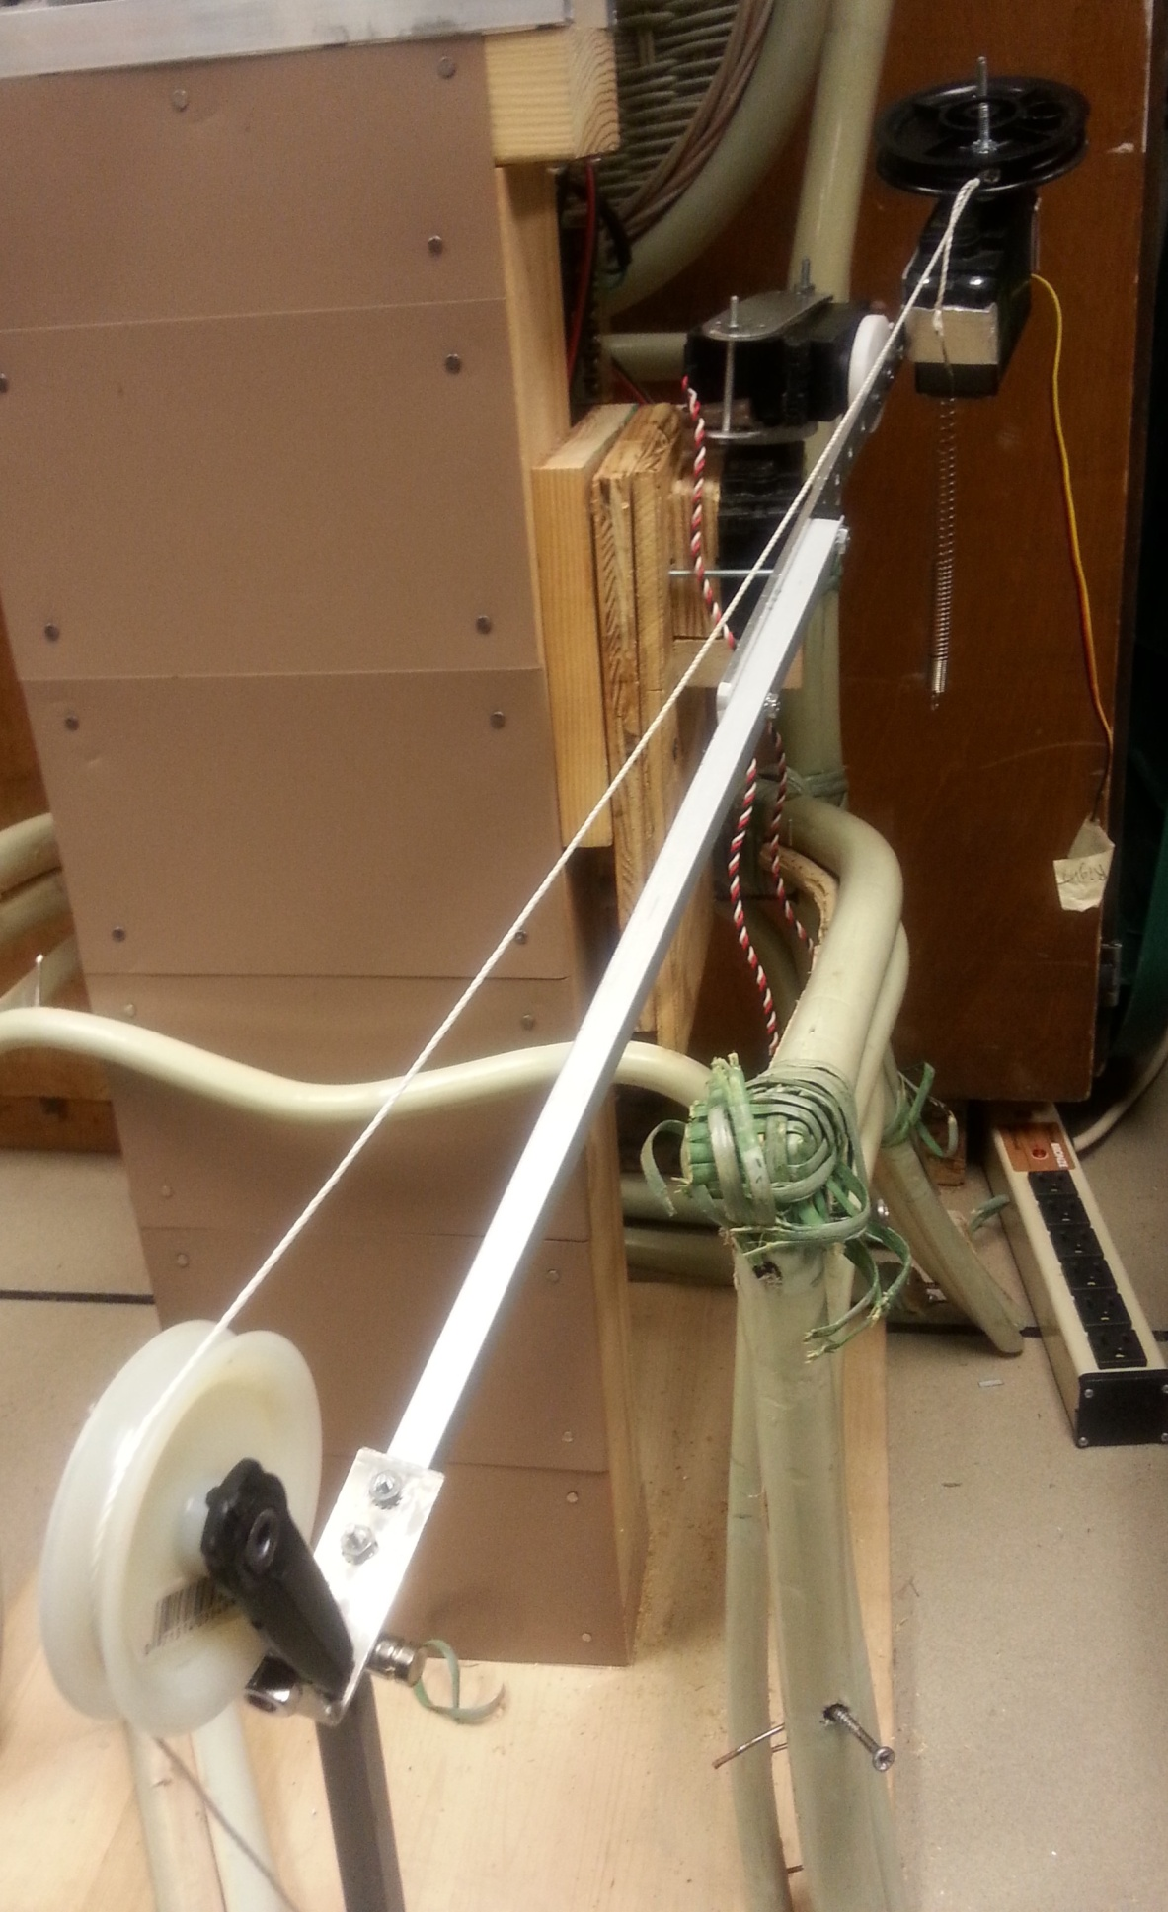

Total Time to Build:

~10 hours

Conclusion:

After we finished assembling all the material together, we tested the servos, and the square metal that was used to replace the brass rods was much sturdier. Two pulleys were attached, one to the hip (attached to a servo) and the other to the knee. This provided enough strength to life the knee and also prevented extra weight to be added to the leg. We tested all the servos and it works as expected.

**Future Project Ideas and Thoughts:**

We had a couple of ideas on implementing the leg that future students may want to try out and see if they get better results.

* Instead of using a spring to counter the weight:
  + Try experimenting using actual weights on the other side, this way more or less weight can be added depending on how much is needed to counter the actual weight.
* Instead of using pulleys to move the knee:
  + Try experimenting with using gears.